*A minor project report on*

“UNIVERSITY ADMISSION MANAGEMENT SYSTEM”

Submitted

*In the partial fulfillment of the requirements for*

Object oriented programming java

By

Radhika.K (181FA04221)

R.Pratyusha (181FA04222)

Shivani.R (181FA04229)

*Under the guidance of*

Mr.M.CHITHAMABARATHANUB.E,M.Tech,Ph.D



**DEPARTMENT OF COMPUTER SCIENCE & ENGINEERING**

**Vignan’s Foundation for Science,Technology& Research**

Deemed to be University

**Vadlamudi, Guntur - 522213, INDIA.**

**Dec-April 2020**



**DEPARTMENT OF COMPUTER SCIENCE & ENGINEEING**

***CERTIFICATE***

This is to certify that the report entitled “**UNIVERSITY ADMISSION MANAGEMENT SYSTEM”** is submitted in the partial fulfilment of course by “**RADHIKA KONDAPANENI(181FA04221), RAVURI PRATYUSHA (181FA04222), SHIVANI RAMBHATLA(181FA04229)”**work of data structures as a minor project, carried out in the department of CSE ,VFSTR deemed to be university.

|  |  |  |
| --- | --- | --- |
| **SIGNATURE** |  | **SIGNATURE** |
| **Dr.Venkatesulu Dondeti,** |  | **M.Chithamabara T hanu** |
| **HEAD OF THE DEPARTMENT**  Professor |  | Assistant Professor |
| Department of CSE |  | Department of CSE |

Submitted for the External Review held on ……………………….

**Internal Examiner External Examiner**

|  |  |  |  |
| --- | --- | --- | --- |
|  |  |  | |
|  | **ABSTRACT** | . | |
|  |  |  | |
| In 21st century, the world is largely dependant on information technology where accuracy , speed and reliability have a huge impact . Manual University Admission Management System” pen and paper work is going to be replaced by computerized systems for more efficient functioning . In the present scenario, it is difficult to keep track of the admission status of a candidate on the day of admission , as the number of candidates applied for higher education institutes is gradually increasing . the aim of the research work is to develop a web based application for University Admission Management System where we can computerize a part of University Admission process to make the admission process easy, efficient and user – friendly .  **TABLE OF CONTENTS**  **CHAPTER PAGENO** | | |  |
| **CHAPTER 1 5**  **1.1 INTRODUCTION TO JAVA** | | |  |
| **ADVANTAGES OF JAVA**  **1.2 EXPLANATION OF THE PROJECT** | | |  |
| **CHAPTER 2 6**  **2.1 SOFWARE REQUIREMENTS**  **2.2 HARDWARE REQUIREMENTS**  **CHAPTER 3 7** | | |  |
| **ACTIVE DIAGRAM** | | |  |
| **CHAPTER 4 8**  **SOURCE CODE**  **CHAPTER 5 17** | | |  |
| **SAMPLE OUTPUTS** | | |  |
| **CHAPTER 6 23** | | |  |
| **6.1 CONCLUSION**  **6.2 FUTURE SCOPE**  **6.3 REFRENCES** | | |  |
|  | | |  |
| **CHAPTER 1** | | |  |
| **1.1 INTRODUCTION TO JAVA:**  Java is an objected oriented programming language. Java has complier and interpreter in Jvm. Java c compiler converts source code into byte code.jvm converts byte code to machine code. Only Jvm can understand byte code instruction, byte code is platform independent where as jvm is a platform dependent. Java developer define a group of instructions to express a java operation. The instructions are called byte code instructions.  **ADVANTAGES OF JAVA:**   * Java derived most of its keywords from c and c++. * It is a platform independent language. * It supports code re usability. * Allow easier processing of data.   **1.2 EXPLANATION OF THE PROJECT:**  The “University Admission Management System” is a web-based database software application . Database is a storehouse of information and treated as a unit for information retrieval purpose . Database software is a set of one or more programs that enables users to create , maintain , organize , and retrieve data from database. It is widely used today in organization to maintain employee data, customer data ,accounting data etc.  This project entitled as “University Admission Management System” will help to make the admission process much easier. Now-a day , on the day of admission, the flow of candidates is very high and it requires both manual processing and record keeping at the same time that makes the process lengthy and difficult to keep track the admission status of a candidate in multiple departments . in this research , we computerize this part of admission management process which makes the process usually faster, more reliable and more accurate than performing these tasks manually. The “University Admission Management System” is a web-based program aimed to make easier and more convenient way for the admission process in educational institution . This system is developed and based on Database Management System | | |  |
|  | | |  |
|  | | |  |
| **CHAPTER 2** | | |  |
| **2.1 Software Requirements:**  Front end : HTML   * Used to create web pages * Format text as titles and headings * Arrange graphics on web pages * To link to different pages within a website   CSS   * Used with any XML-based markup language * For describing the presentation of web pages ,including colors , layouts and fonts   Operating system : Windows XP/2003  **2.2 Hard ware requirements:**  System : Pentium dual core  Hard disk and RAM : 120GB and 1GB  Programming Language : Java  Database : My SQL  Integrated Development Environment (IDE) : Spring tool suite  Back end : My SQL -used for inserting data into tables using  java program(JDK)  Connectivity : JDBC( Java Database Connectivity ) used for connecting front end and back end. | | |  |
|  | | |  |
|  | | |  |
|  | | |  |

**CHAPTER 3**

**Active diagram:**

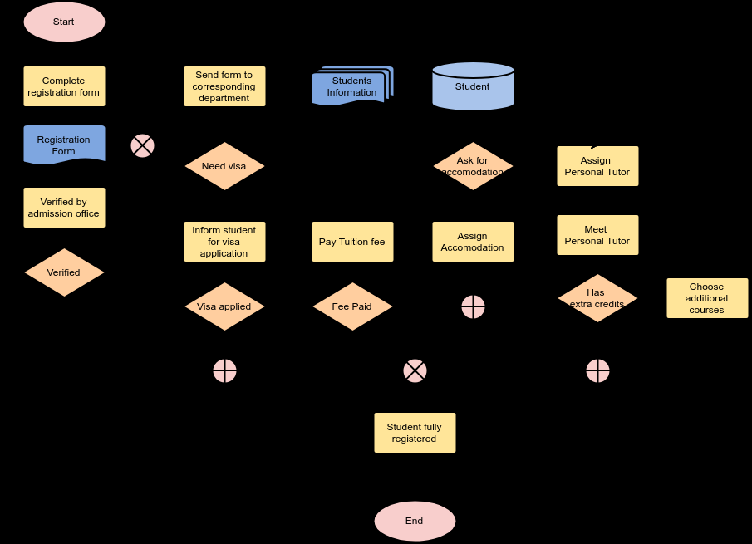

**CHAPTER 4**

**Source code:**

**Sqlconnection:**

**import java.sql.*;  
import java.util.ArrayList;  
import java.util.List;  
  
public class MysqlCon {  
private Connection getConnection()  
{  
Connection con=null ;  
try {  
Class.forName("com.mysql.jdbc.Driver");  
con = DriverManager.getConnection("jdbc:mysql://localhost:3306/rk", "root", "root");  
return con;  
} catch (Exception e) {  
System.out.println(e);  
}  
return con;  
}  
public String saveDetails(String fname,String lname,long phno,String branch,String email)  
{  
boolean boo=false;  
try {  
Connection con=getConnection();  
PreparedStatement ps=con.prepareStatement("insert into students(fname,lname,Phno,branch,email) values(?,?,?,?,?)");  
ps.setString(1,fname);  
ps.setString(2,lname);  
ps.setLong(3, phno);  
ps.setString(4,branch);  
ps.setString(5,email);  
boo=ps.execute();  
ps.close();  
con.close();  
return "s";  
} catch (Exception e) {  
// TODO Auto-generated catch block  
e.printStackTrace();  
}  
return "n";  
}  
  
public String editDetails(Student s) {  
  
try {  
Connection con=getConnection();  
PreparedStatement ps=con.prepareStatement("update students set fname=?,lname=?,Phno=?,branch=?,email=? where ID=?");  
ps.setString(1,s.getFname());  
ps.setString(2,s.getLname());  
ps.setLong(3, s.getPhno());  
ps.setString(4,s.getBranch());  
ps.setString(5,s.getEmail());  
ps.setInt(6, s.getSid());  
ps.executeUpdate();  
ps.close();  
con.close();  
return "s";  
} catch (Exception e) {  
// TODO Auto-generated catch block  
e.printStackTrace();  
}  
return "no";  
  
}  
public ArrayList<Student> studentlist()  
{  
ArrayList<Student> al=new ArrayList<Student>();  
try {  
Connection con=getConnection();  
Statement stmt = con.createStatement();  
ResultSet rs = stmt.executeQuery("select * from students");  
while (rs.next())  
{  
Student s=new Student();  
s.setSid(rs.getInt(1));  
s.setFname(rs.getString(2));  
s.setLname(rs.getString(3));  
s.setPhno(rs.getLong(4));  
s.setBranch(rs.getString(5));;  
s.setEmail(rs.getString(6));  
al.add(s);  
}  
con.close();  
} catch (Exception e) {  
System.out.println(e);  
}  
return al;  
}  
  
public boolean deleteStudent(int id) {  
boolean result=false;  
try {  
Connection con=getConnection();  
PreparedStatement ps=con.prepareStatement("delete from students where ID=?");  
ps.setInt(1, id);  
result  = ps.execute();  
  
return result;  
}catch (Exception e) {  
// TODO: handle exception  
}  
return result;  
}  
  
public Student getStudentbyId(int id) {  
Student s=null;  
try {  
Connection con=getConnection();  
PreparedStatement ps=con.prepareStatement("select * from students where ID=?");  
ps.setInt(1, id);  
ResultSet rs = ps.executeQuery();  
while (rs.next())  
{  
s=new Student();  
s.setSid(rs.getInt(1));  
s.setFname(rs.getString(2));  
s.setLname(rs.getString(3));  
s.setPhno(rs.getLong(4));  
s.setBranch(rs.getString(5));;  
s.setEmail(rs.getString(6));  
  
return s;  
}  
  
}catch (Exception e) {  
// TODO: handle exception  
}  
return s;  
}  
}**

**universityservlet:**

**import java.io.IOException;  
import java.io.PrintWriter;  
import java.sql.Connection;  
import java.sql.DriverManager;  
import java.sql.PreparedStatement;  
import java.sql.SQLException;  
  
import javax.servlet.ServletException;  
import javax.servlet.annotation.WebServlet;  
import javax.servlet.http.HttpServlet;  
import javax.servlet.http.HttpServletRequest;  
import javax.servlet.http.HttpServletResponse;  
  
/**  
 * Servlet implementation class UniversityServlet  
 */  
@WebServlet("/UniversityServlet")  
public class UniversityServlet extends HttpServlet {  
private static final long serialVersionUID = 1L;  
         
    /**  
     * @see HttpServlet#HttpServlet()  
     */  
    public UniversityServlet() {  
        super();  
        // TODO Auto-generated constructor stub  
    }  
  
/**  
* @see HttpServlet#doGet(HttpServletRequest request, HttpServletResponse response)  
*/  
     
protected void doGet(HttpServletRequest request, HttpServletResponse response) throws ServletException, IOException {  
// TODO Auto-generated method stub  
//response.getWriter().append("Served at: ").append(request.getContextPath());  
response.setContentType("text/html");//setting the content type    
PrintWriter pw=response.getWriter();//get the stream to write the data    
   
//writing html in the stream      
String s1=request.getParameter("fname");  
String s2=request.getParameter("lname");  
String s3=request.getParameter("ph_no");  
  
long phno = Long.parseLong(s3);  
String s4=request.getParameter("branch");  
String s5=request.getParameter("email");  
MysqlCon ms=new MysqlCon();  
String save=ms.saveDetails(s1,s2,phno,s4, s5);  
if(save.equals("s"))  
{  
request.setAttribute("message", "New Student is Added");  
request.getRequestDispatcher("/StudentList").forward(request, response);  
}  
else  
{  
pw.println("<html><body>");  
pw.println("Sorry");  
pw.println("</body></html>");  
}  
}  
  
/**  
* @see HttpServlet#doPost(HttpServletRequest request, HttpServletResponse response)  
*/  
protected void doPost(HttpServletRequest request, HttpServletResponse response) throws ServletException, IOException {  
// TODO Auto-generated method stub  
doGet(request, response);  
}  
  
}**

**studentlist:**

**import java.io.IOException;  
import java.io.PrintWriter;  
import java.util.ArrayList;  
  
import javax.servlet.ServletException;  
import javax.servlet.ServletRequest;  
import javax.servlet.annotation.WebServlet;  
import javax.servlet.http.HttpServlet;  
import javax.servlet.http.HttpServletRequest;  
import javax.servlet.http.HttpServletResponse;  
  
/**  
 * Servlet implementation class StudentList  
 */  
@WebServlet("/StudentList")  
public class StudentList extends HttpServlet {  
private static final long serialVersionUID = 1L;  
         
    /**  
     * @see HttpServlet#HttpServlet()  
     */  
    public StudentList() {  
        super();  
        // TODO Auto-generated constructor stub  
    }  
  
/**  
* @see HttpServlet#doGet(HttpServletRequest request, HttpServletResponse response)  
*/  
protected void doGet(HttpServletRequest request, HttpServletResponse response) throws ServletException, IOException {  
// TODO Auto-generated method stub  
MysqlCon fix=new MysqlCon();  
ArrayList<Student> al=fix.studentlist();  
PrintWriter out=response.getWriter();//get the stream to write the data    
request.setAttribute("list",al);  
Object mesage=request.getAttribute("message");  
if(mesage!=null)  
request.setAttribute("message", mesage.toString());  
request.getRequestDispatcher("Studentlist.jsp").forward(request, response);  
}  
/**  
* @see HttpServlet#doPost(HttpServletRequest request, HttpServletResponse response)  
*/  
protected void doPost(HttpServletRequest request, HttpServletResponse response) throws ServletException, IOException {  
// TODO Auto-generated method stub  
doGet(request, response);  
}  
  
}**

**student:**

**public class Student {  
private int sid;  
private String fname;  
private String lname;  
private String branch;  
    private long phno;  
    private String email;  
public int getSid() {  
return sid;  
}  
public void setSid(int sid) {  
this.sid = sid;  
}  
public String getFname() {  
return fname;  
}  
public void setFname(String fname) {  
this.fname = fname;  
}  
public String getLname() {  
return lname;  
}  
public void setLname(String lname) {  
this.lname = lname;  
}  
public String getBranch() {  
return branch;  
}  
public void setBranch(String branch) {  
this.branch = branch;  
}  
public long getPhno() {  
return phno;  
}  
public void setPhno(long phno) {  
this.phno = phno;  
}  
public String getEmail() {  
return email;  
}  
public void setEmail(String email) {  
this.email = email;  
}  
Student()  
{  
  
}  
}**

**editform:**

**import java.io.IOException;  
import java.io.PrintWriter;  
import java.util.ArrayList;  
  
import javax.servlet.ServletException;  
import javax.servlet.annotation.WebServlet;  
import javax.servlet.http.HttpServlet;  
import javax.servlet.http.HttpServletRequest;  
import javax.servlet.http.HttpServletResponse;  
  
/**  
 * Servlet implementation class StudentCurd  
 */  
@WebServlet(description = "Stdent curd opearations", urlPatterns = { "/StudentCurd" })  
public class StudentCurd extends HttpServlet {  
private static final long serialVersionUID = 1L;  
         
    /**  
     * @see HttpServlet#HttpServlet()  
     */  
    public StudentCurd() {  
        super();  
        // TODO Auto-generated constructor stub  
    }  
  
/**  
* @see HttpServlet#doGet(HttpServletRequest request, HttpServletResponse response)  
*/  
     
protected void doGet(HttpServletRequest request, HttpServletResponse response) throws ServletException, IOException {  
// TODO Auto-generated method stub  
String action=request.getParameter("action");  
String id=request.getParameter("id");  
  
if(action.equals("edit")) {  
MysqlCon con=new MysqlCon();  
Student stu=con.getStudentbyId(Integer.parseInt(id));  
request.setAttribute("stu",stu);  
request.getRequestDispatcher("Edituser.jsp").forward(request, response);  
}else {  
MysqlCon con=new MysqlCon();  
boolean result=con.deleteStudent(Integer.parseInt(id));  
request.setAttribute("message", "Student is Deleted");  
request.getRequestDispatcher("/StudentList").forward(request, response);  
  
}  
  
  
}  
/**  
* @see HttpServlet#doPost(HttpServletRequest request, HttpServletResponse response)  
*/  
protected void doPost(HttpServletRequest request, HttpServletResponse response) throws ServletException, IOException {  
// TODO Auto-generated method stub  
String s1=request.getParameter("fname");  
String s2=request.getParameter("lname");  
String s3=request.getParameter("ph_no");  
long phno = Long.parseLong(s3);  
String s4=request.getParameter("branch");  
String s5=request.getParameter("email");  
String sid=request.getParameter("sid");  
Student s= new Student();  
s.setSid(Integer.parseInt(sid));  
s.setFname(s1);  
s.setLname(s2);  
s.setPhno(phno);  
s.setBranch(s4);  
s.setEmail(s5);  
MysqlCon con=new MysqlCon();  
String result=con.editDetails(s);  
if(result.equals("s")) {  
request.setAttribute("message", "Student is Updated");  
request.getRequestDispatcher("/StudentList").forward(request, response);  
}  
  
}  
  
}**

**CHAPTER 5**



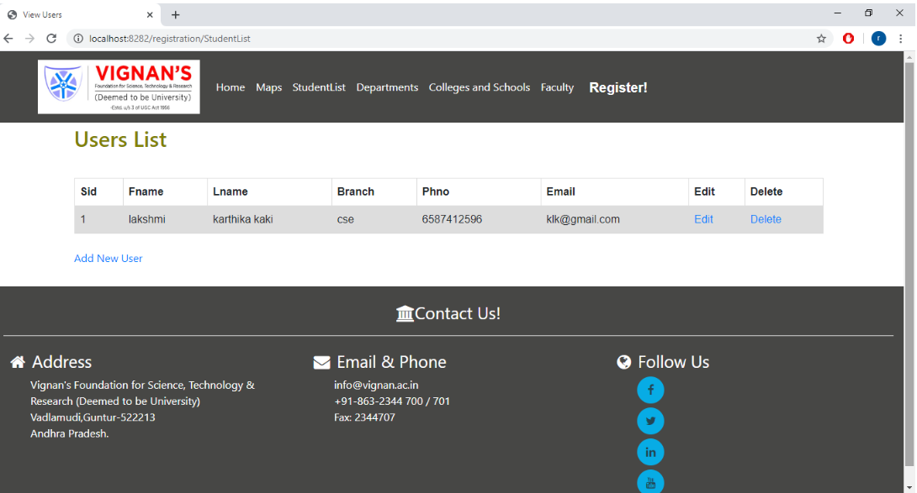

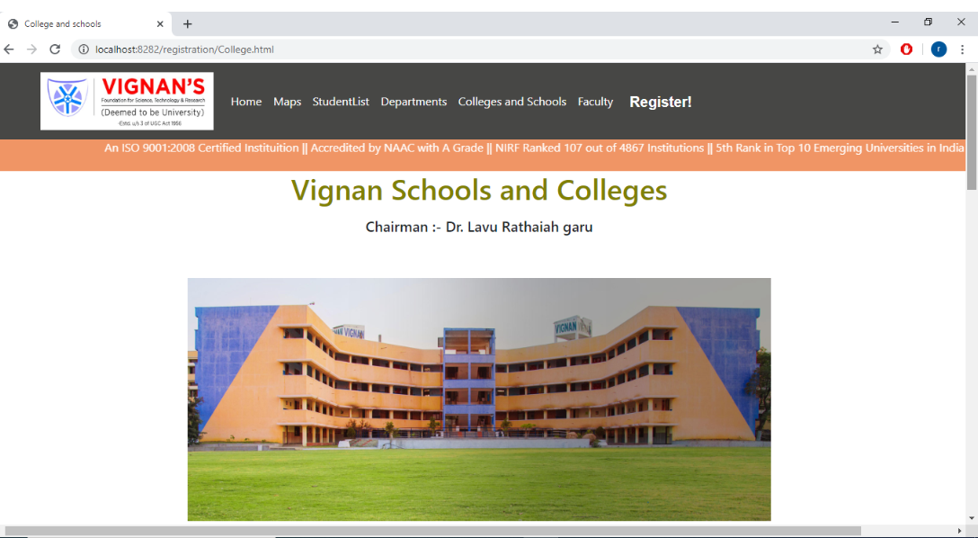

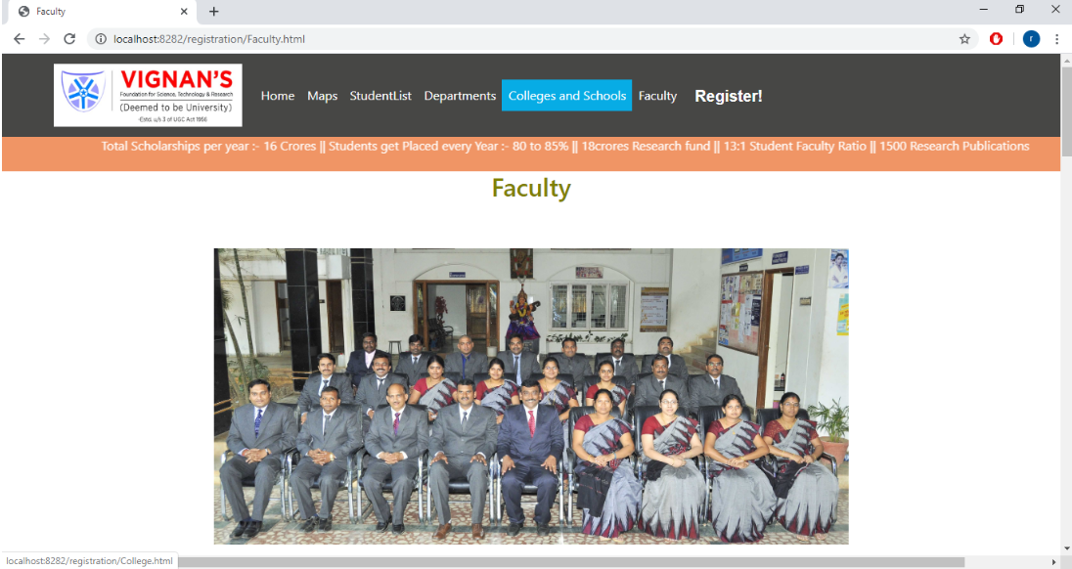

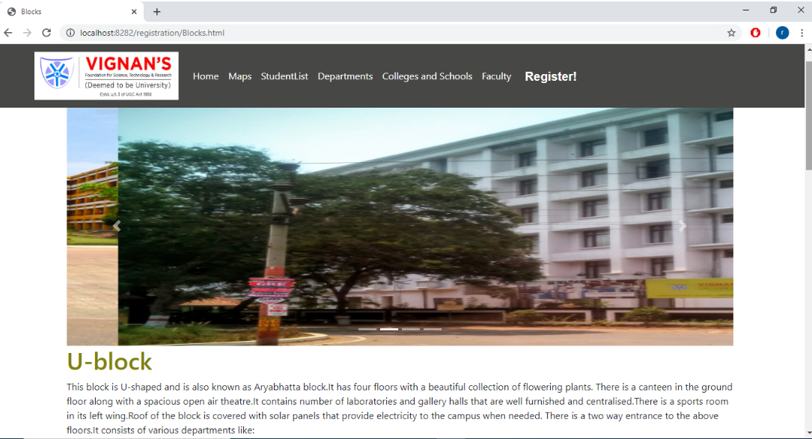

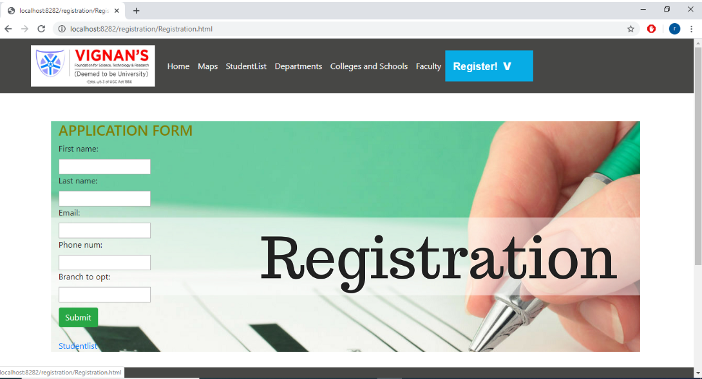

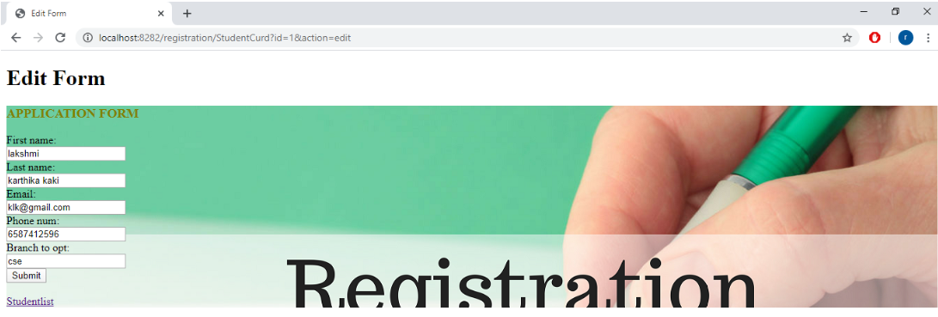



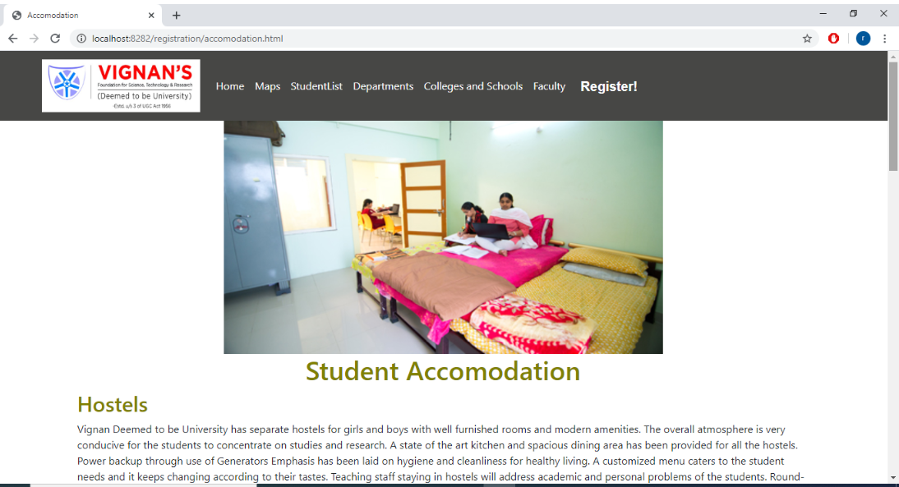

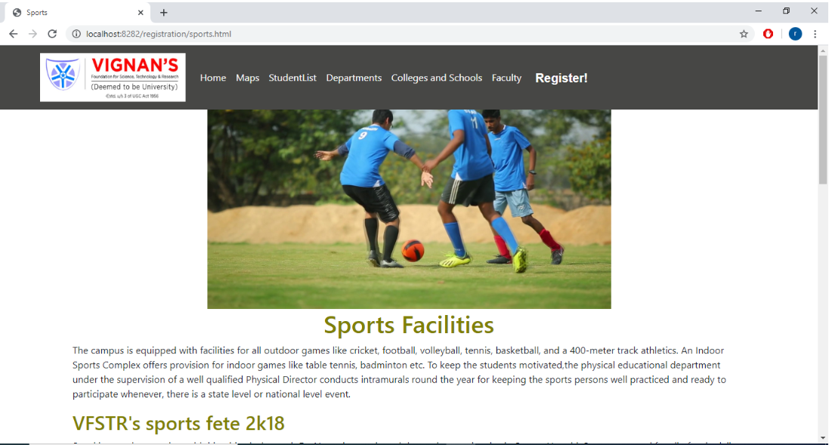

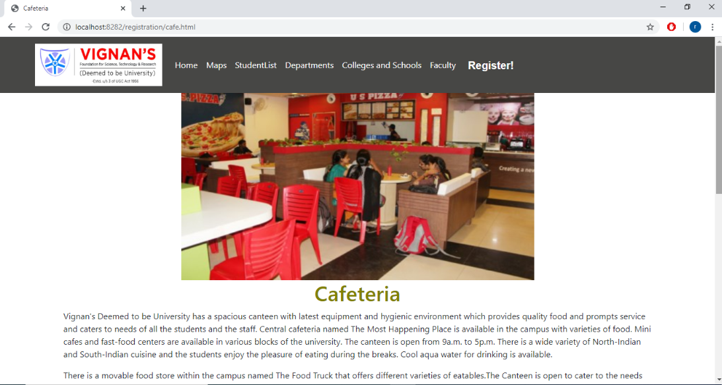

**CHAPTER 6**

**6.1 Conclusion:**

A computerized system provides flexibility, effectiveness and efficiency, plus it proves to be economical in the long run. The proposed university admission management system integrates all the features of a web – based system. As per user requirements, new features and modules can be added to the system.

**6.2 Future scope:**

It will store all the personal and academic information of the students. It will also store the fee information of the students. **Management** will get information of any student who studied/studying in this institute till now easily.

**6.3 References:**

<https://www.freeprojectz.com/python-django-project/university-admission-management-system>

<http://www.computerscijournal.org/vol11no1/design-and-development-of-university-admission-management-system/>

<https://www.iitms.co.in/onlineadmission.html>